Assignment 3 (September 26 – October 1)

1. Prove that any intersection of closed sets is closed.

2. For each of the following subsets of 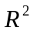 , a) sketch the set and b) determine whether or not it is ореn, closed or cоmрact. Give reasons for your negative answers to part b .
a) 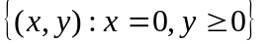, b) 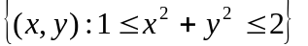, c) 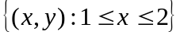,
d) .

3. Sketch level sets for each of the following functions from 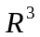 to 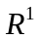:
a) 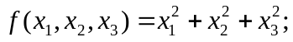 b) 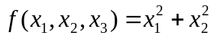;
c) 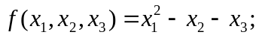 d) 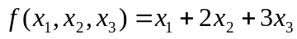

4. Does the following limit exist: 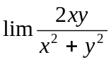 as 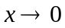 and 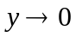 ?

5. Find points of discontinuity of the following functions:
a) 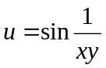; b) 